**ECE324: DIGITAL SIGNAL PROCESSING LABORATORY**

**Marks Obtained**

**Job Execution (Out of 40):_________**

**Online Submission (Out of 10):________**

**Practical No.: P2 (Should be according to your allotted practical sequences. Not according to your IP or your wish. )**

**Roll No.: E1403 B30 Registration No.: 11411765 Name: Melvin Felix**

**Note:**

* All programs should be completed **without using inbuilt function of MATLAB**.
* Aim of the practical should be according to the IP.
* In Mathematical expressions write all formulas or equations which you are going to implement on MATLAB for completion of the allotted practical. (Use ‘Insert equation’ feature of MS office if required).
* In Program Code section, copy your m-file content and paste it. **Don’t change any font size/style/color in this section**.
* Don’t write and comment statement in m-file.
* Upload your report in ‘PDF’ format on UMS, also submit your M-files to your instructor in proper format**\***.
* Fill the check list section before submission **and sign it**.

**Aim:** To make a MATLAB function for calculating linear convolution of given signal

1. Find the linear convolution of a time limited sine and cos sequence

2. Find the linear convolution of a time limited sine and exponential sequence

**Mathematical Expressions Required: exp(), sin(), flipud(). length(), zeros(), sum()**

**Inputs (Should be allocated by the Instructor, Individually):**

**(__________________)**

**Signatures of Instructor**

MATLAB Code:(1A)

%convolution of two sequences

%

%

%

%

%

function[y_op] = linear_convolution_mf(x_ip,y_ip)

l_x = length(x_ip); %length of the input

l_h = length(h_ip); %length of the second input

l_y = l_x + l_h - 1;

y_op = zeros(1,l_y);

x = [x_ip zeros(1,(l_y-l_x))];

h = [h_ip zeros(1,(l_y-l_h))];

h_trans = h';

y_mul = h_trans*x;

y_mult = flipud(y_mul);

loop_run = l_y-1;

for i = 1:l_y

y_op(i) = sum(diag(y_mult,-(loop_run)));

loop_run = loop_run - 1;

end

end

Part (1B):

t = 0:.01:1;

x_sin = sin(2*pi*3*t);

y_cos = cos(2*pi*2*t);

y1 = linear_convolution_mf(x_sin,y_cos);

z1 = conv(x_sin,y_cos);

figure

plot(y1)

figure

plot(z1)

z_exp = exp(t);

y2 = linear_convolution_mf(x_sin,z_exp);

z2 = conv(x_sin,z_exp);

figure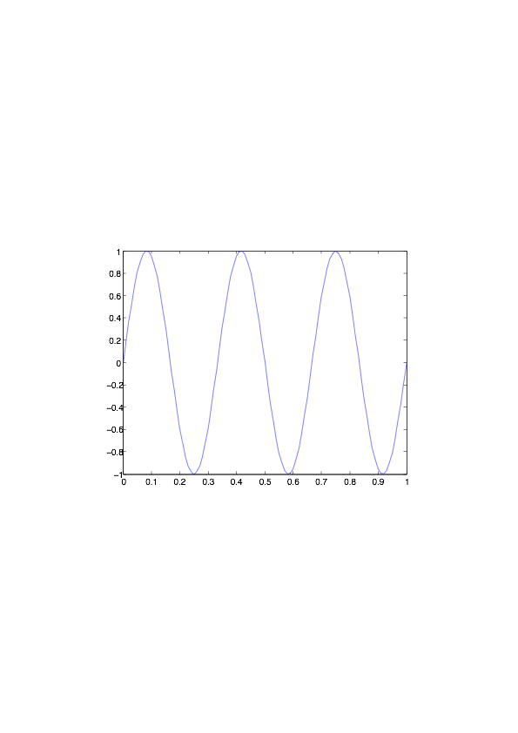

plot(y2)

figure

plot(z2)

**Graphs**:

1. Input Sine

2.**Input cos**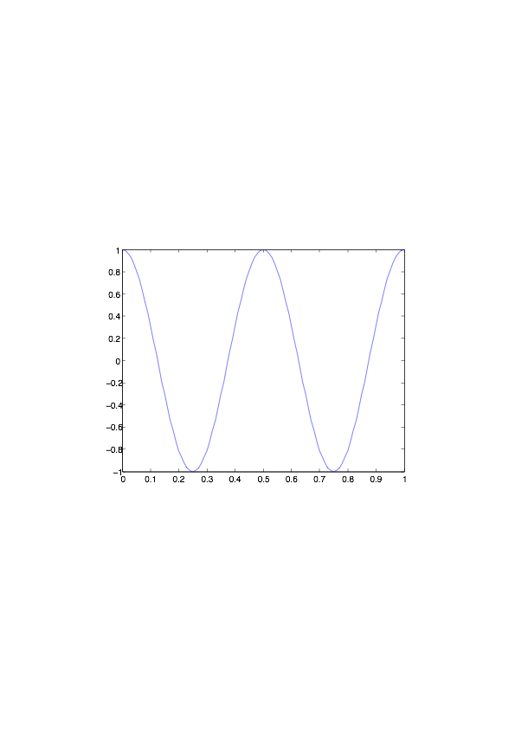

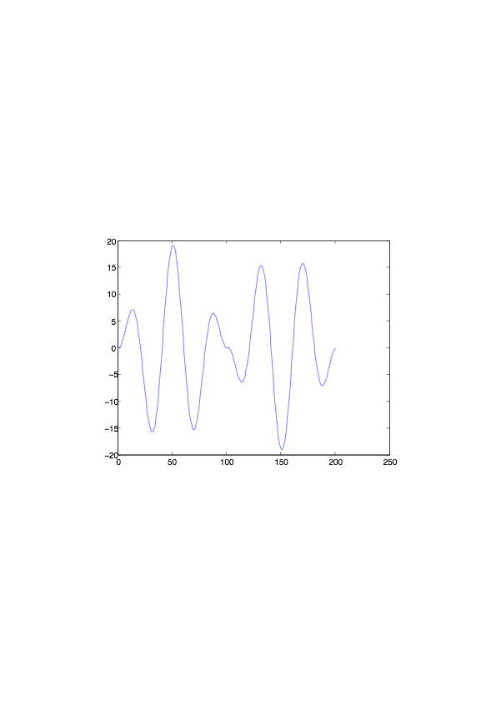

**3.Output convoluted wave**

**4.Input exp**

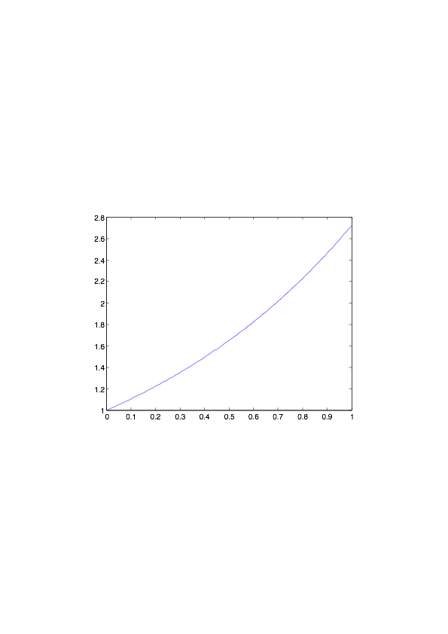

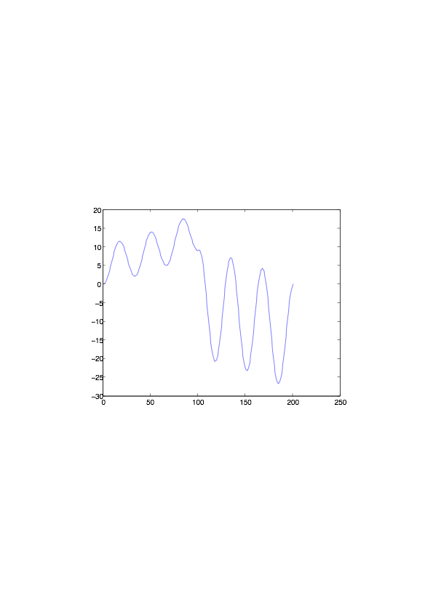

**Output:**

**Analysis/ Learning outcomes:**

1. I’ve learnt how to calculate the convolution of two time limited sequences and verified it using the in-built function
2. I’ve learnt the theory behind convolution and it’s implementation
3. I’ve learnt how to create and name a function in a given file

|  |  |
| --- | --- |
| **Check list before submission** | **By Student (Yes/No)** |
| Have you used any in-built function? | Yes |
| Have you written the description of each variable in work space? | Yes |
| Have you written the description of each figure in your results? | No |
| Have you compared your function output with the in-built function? | Yes |
| Did you analysis the results and outcomes properly? | Yes |
| Are you going to submit your report in PDF format? | Yes |
| Have you named your function files according to the **Student’s Function Name Format?** | Yes |

(_________________)

**Signature of Student**

**\*Student’s Function Name Format**

* Let the roll number of the student be **RE0000A000**, and he want to submit practical number two (**P2**). In this program he make a function which work similar as in built function ‘**conv**’ so m-file name must be **‘RE0000A000P2conv’** . )
* Second M-file/function which has to be written to get the outputs for the allocated inputs by using first function **RE0000A000P2conv**, must be named as ‘**RE0000A000P2**’